Load Testing DescartesResearch/TeaStore using Jmeter and Locust

Fadil Husain
fadil.husain@ucalgary.ca
Bill Thai
billthai12@gmail.com
Alexey Grekov
Alexey.grekov.ag@gmail.com
Daniel Le
daniel.le1@ucalgary.ca

Preamble
Here is the link to a public Github repository (repo) [1], https://github.com/FDIL501st/SENG533-Project-Data. The repo contains the data we recorded from our experiement.
It contains more data than what is presented in this paper. The reason why some data was not presented in this paper as it didn't directly relate to the topic of this paper. One such example is the standard deviation for each average.
Abstract—In this paper, we discuss the results of load testing TeaStore [1], a micro-service application. Our goal was to understand how the TeaStore handles varying user loads, identify potential bottlenecks in service types, and determine the failure rates of the system. We seek to answer three main questions outlined in our “Main Performance Evaluation Questions” section. Using performance testing tools Jmeter and Locust we simulated HTTP requests to our server deployed in the cloud with system specifications of 4vCPUs and 8 GB RAM. The load tests ranged from 10 to 5,000 users to test the application’s scalability. Our findings from our tests show some challenges with scalability in the TeaStore. Initial loads to 100 users saw a steep increase in response which then decreased a bit for the rest of the loads in response times. We determined that our two primary bottlenecks in services were “Home” and “Login”. If we expect an average response time of 1s, then we found that TeaStore can handle up to about 100 concurrent users. For a 95% percentile response time of 1s, then TeaStore can handle about 50 concurrent users.
Keywords—load testing, micro-service, response time, TeaStore

Introduction

Problem
The project we selected addresses the TeaStore, developed by the Descartes Research Group at the University of Wurzburg. This website serves as a platform for customers to purchase various types of tea.TeaStore is a micro-service application we can run tests on with the tools Locust and Jmeter. The store contains UI elements for database generation and includes the store itself. The application has five main services that communicate via REST with a Netflix Ribbon load balancer. The TeaStore is an important problem for us, as it allows us to explore software performance evaluation techniques. Key takeaways from the problem are learning how to use load generators to send HTTP requests to test a micro-service application. Data we gained from the tests we then learned how to determine system weak points or bottlenecks while performing CI calculations. More importantly, it ensures our TeaStore business can scale up with more customers and maintain a relatively low response time to maximize sales. One reason for picking this problem out of the rest is the ease of use. Application is pre-coded for us and the provided instructions make it easy to deploy with Docker Compose.
The repo for TeaStore can be found in [2] of references.

What others have done
The research paper “Microservices: A Performance Tester’s Dream or Nightmare?” [4], discusses some of the benefits and challenges of performance testing on microservice applications specifically the TeaStore. Some questions that get answered are “How stable are the execution environments of microservices across repeated runs of the experiments?” and “How stable are the performance testing results across repeated runs of the experiments?”. From experiments, they concluded that execution environments of microservices are not stable across runs and although CPU busy times are roughly the same there can be significant differences in response times. Differences in response time results can give testers a poor perception of the system and make running CI calculations harder.

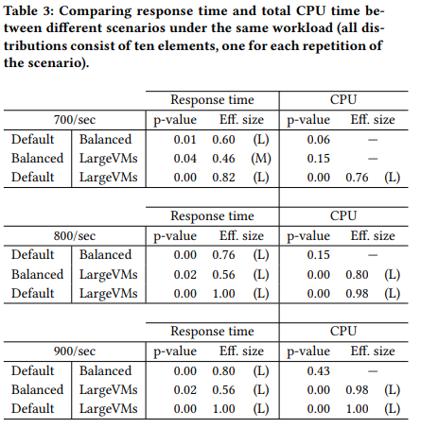

Fig. 1 above shows large differences in medium or large effect sizes across the paired scenarios and the three workloads examined in the research paper. Performance testing results with higher workloads lead to greater variance in response time data gained from the TeaStore from Figure 2 (in the research paper). These variances show the unreliability of microservices execution environments. Repeated experiments may yield inconsistent performance results and relying on a single experiment run results in poorly done performance tests.

To address some of the pitfalls of microservices and apply the knowledge gained from the experiments of the research paper, we created our approach. We assumed that users would typically access the website while the server had been running for some time already. The server running before would allow for any TeaStore caches to be filled up and would allow us to gain more consistent data. An issue we encountered before was our initial results had a significant difference compared to the same runs of the experiment later. To fix this, we ran our TeaStore once with a Locust load to fill caches before starting our experiment. We also ran our experiments multiple times as we learned that microservices can produce unreliable test results and from the findings of question 3 of the research paper on single experiment runs. Some additional tests we decided to do that weren’t done in the work of the research paper were response time tests for specific pages and the number of requests with the number of failures.

Main Performance Evaluation Questions
To evaluate the performance of the TeaStore we have come up with three questions we seek to answer. For the first question, we test the TeaStore with different amounts of user workloads as described in our experiment process section. From the response time values we measure to see how quickly the TeaStore can respond. In the second question, we get more specific and look at the individual services to determine our bottleneck in response times. Lastly, we look at how the number of requests and users affect the failure rate of our system.

- How does the entire TeaStore handle increasing workloads?
- What are the response times of different service requests by the TeaStore?
- How does the number of requests affect the failure rate?

Evaluation Technique and Main Findings
For the evaluation technique, we used the tools Jmeter and Locust to measure response times and request failure rates. Experiments were done on a cloud machine hosting the TeaStore using DockerCompose with system specifications of 4 vCPUs and 8 GB RAM. This server was accessed using a laptop that ran our tools. We tested user loads ranging from 10 to 5,000 users to observe TeaStore’s performance while keeping the TeaStore running between tests to avoid the cache becoming empty. These experiments provided data on the system’s overall response time, the response time of individual services, and failure rates across different user loads. When conducting these experiments, we performed multiple runs with the specific tool to account for the variability in microservice environments as suggested by prior research on the potential instability of performance metrics in microservice applications. From the data collected, we conducted 95% confidence interval calculations for response times. From our results, we created graphs and analyzed trends to understand the relationship between load and system performance.

Q1 Findings
TeaStore’s performance in 95% response time increases the most from 0 to 100 user load with the steepest line then from 100 to 500 user response still increases but at a slower rate. From 500 users onward the 95% response time follows a linear trend where the slope is the second steepest, the steepest being from 0 to 100 users. These findings are made from Fig. 7/8 in the Locust Results section. Note that in Fig. 8 the x scale is smaller making the two slopes look similar but in a bigger scale for Fig. 7 these slopes make big differences but are hard to tell. We can see from the graphs the entire system performs poorly on the initial startup to 100 users and continues to perform relatively poorly from 500 users onward. Optimizations can still be made on how the TeaStore scales with an increased number of users.

Q2 Findings
From Fig. 5, we determined that “Home” and “Login” services are our highest response times for service request types with a high number of users. Our best-performing service was “List Product with Different Page” with the lowest response time. To optimize our TeaStore’s performance we can reduce the response times in our bottlenecks in Home and Login services. We will see a greater return on time spent on these services compared to other services. From startup to 100 users all the services perform relatively the same with insignificant differences making it unclear where to put time in. According to Fig. 5, the load between 100 to 500 users is where the most significant differences show, with the “Home” service starting to perform the best towards the end but falls off later.

Q3 Findings
Fig. 9 shows that the number of requests does not directly correlate with the number of failures. The number of users does affect the failure rate, where failure increases with more users. Due to the failure rate not reaching a maximum or showing a flattening trend, we can determine that the TeaStore has not reached its maximum capacity and can still receive more users. A potential explanation for the lack of impact from the number of requests could be due to how microservice architectures work. Additionally, the use of a Netflix Ribbon load balancer by the TeaStore to distribute incoming requests on many services can be a reason.

Background

Required Background to Understand Report
You need to be familiar with TeaStore, the software we are testing. The repo can be found here, https://github.com/DescartesResearch/TeaStore.
You also need to be familiar with Jmeter and Locust, what they are and how they are run.

Experiment

Experiment Design
This experiment was designed to test the ability of a server to run TeaStore. We used docker to build and run TeaStoreas. Ideally we wanted Kieker reports to see metrics of server resources being used, on top of response time from the client. However we were unable to get Kieker to generate reports.
We wanted to simulate a long running server. By this we meant the server's caches being filled with TeaStore related data. We thought this was appropriate as when accessing a site, it is most likely the server was running for a long time before your visit, thus the caches of the server are not empty. When running Locust on a newly started TeaStore, we saw a lower response time, which then grew a bit later in time. We assumed this is most likely due to caches being initially all missing. For our experiment, we didn’t want to include such results. Thus whenever we started up TeaStore, we ran a load on it with Locust to get its caches filled up with data. We decided the variability as what is in the cache as something allowable for this experiment.

Experiment Setup
TeaStore was run on a cloud machine (Cybera Rapid Access Cloud) with 4 vCPUs and 8 GB RAM (will be now referred to as “ server”) using docker-compose_default.yaml that came with the TeaStore repo in TeaStore/examples/docker. Here is a screenshot of the cloud machine specs:
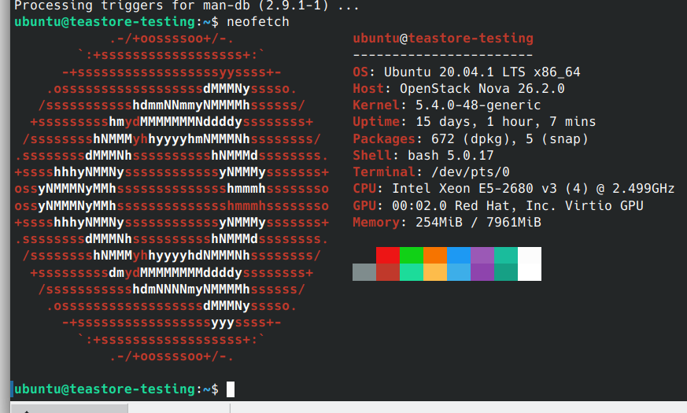

- server snapshot using neofetch

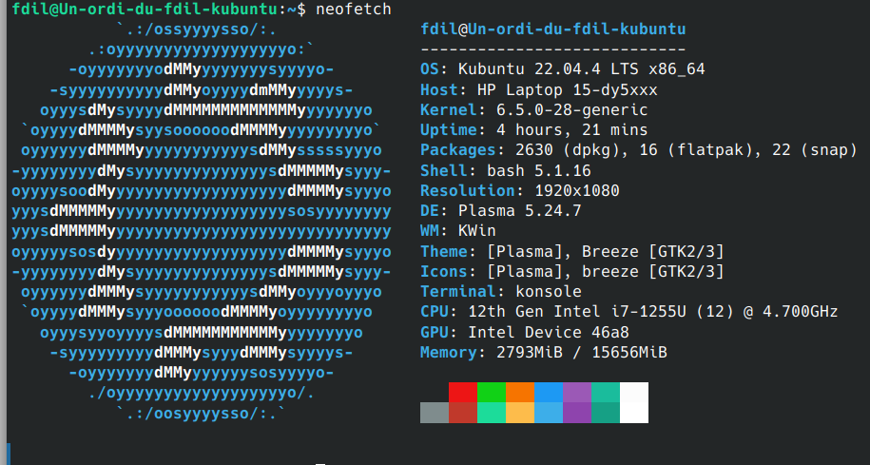
- client snapshot using neofetch

TeaStore was accessed from a laptop (from now referred to as the “client”), using ssh port forwarding. We forwarded port 8000 of the server to port 8000 to the client. The client specs are shown in Fig. 3.
The client is where Jmeter and Locust were run from. This was to ensure that the machine running TeaStore was only running TeaStore (processes that are always running were not touched). The client during load generation also didn’t run applications other than the load generator. With Locust, a web browser tab (web browser used was Opera) was opened up so Locust could be used, however this didn’t make a significant impact on the CPU and RAM resources of the client.

Experiment Process
We chose the following number of users for our load: 10, 50, 100, 500, 1000, 5000. 5000 was chosen to be a load past the stability of the TeaStore as the past 1000 concurrent users is when we saw frequent errors starting to occur due to the server being unable to open more files or connections.

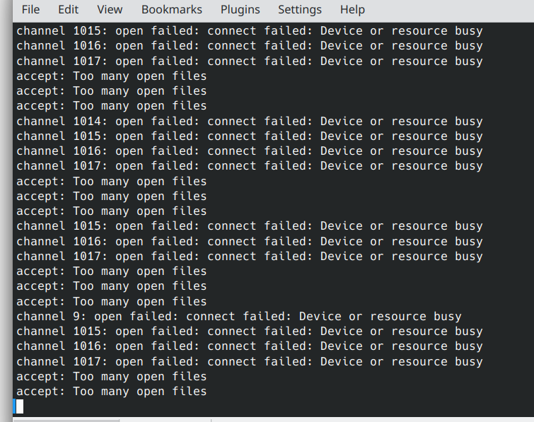

- Error messages from a Locust n=5000 run
Between each run, we did not stop running TeaStore on the server. This is per our experiment design of not emptying the caches. We did stop TeaStore occasionally between our experiments as we were taking a long break. This was to save resources on the cloud machine we were using. When we started running TeaStore again, we gave it a load with Locust to fill up the caches of the server before doing our runs.

Jmeter
For each load, we did 5 runs. After each run, we would save the results as a CSV, clear the results and do the next run. This way we got 5 independent runs for each load. For each run, we used the GUI test plan provided in the TeaStore repo in TeaStore/examples/jmeter. We let the loop amount be 5, meaning each user would run the test script 5 times. The ramp-up time for users 10, 50 and 100 we kept as 10s. For 500 the ramp-up time was 50s, 1000 was 100s and 5000 was 100s. This was to keep it consistent with the Locust ramp-up. However, with 5000, we went with a faster ramp-up time of 100s (Locust the ramp-up was slower). The reason was we found that with a 500s ramp-up time, TeaStore would never reach 500 concurrent users but max out at around 2000 because thousands of users finish their test plans. So we made the ramp-up time faster. With this change, the number of concurrent users still did not reach 5000, but we used it as we didn’t want those runs to have a faster ramp up than 1000 users.

Locust
With Locust, we did not do 5 runs for each load. This was because for 500, 1000, and 5000 users, their runs lasted 1-3 hours each. We were unable to keep the client reserved for this experiment for fifteen 1-3 hour runs. For those three loads, we only got 3 runs each. For the test plan, we used the locust script provided in the TeaStore repo in TeaStore/examples/locust. For the host we used: http://localhost:8080/tools.descartes.teastore.webui/.

Loads 10, 50 and 100 users both had a ramp-up time of 10s and the runs lasted 70s. This is so we can use 60s for data. 500, 1000 and 5000 users had a ramp-up of 10 users/s. We didn’t do a 10s ramp-up time because we found the server failing during such a quick ramp-up. We wanted to test a stable server, so we slowed down the ramp up to 10 users/s. We were also doing longer runs because the average response time was rising until it peaked. We wanted to capture this peak, thus we had 2-hour runs for 500 and 1000 users. For 5000 users we knew the server was unstable, so we just had 1 hour runs.
After each run, we would save the result HTML Locust provides. For our data, we read from the chart at the bottom, we pick the visible dots as points in time to record the response times. For the averages for each run, we would only consider data at which we have reached the number of users we were testing. This means we ignored the first few points of data where the load was still ramping up.

Results

Jemeter
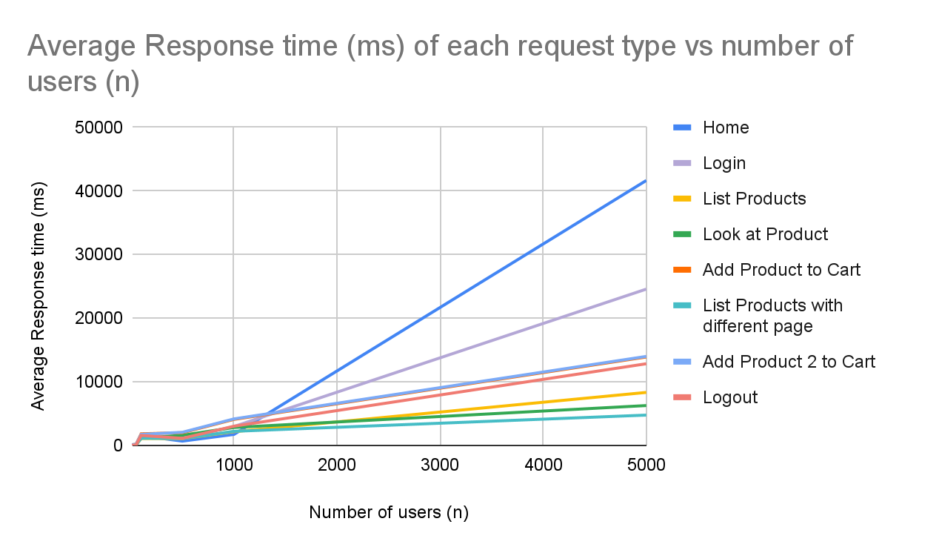

- Line graph of Average response times from Jmeter

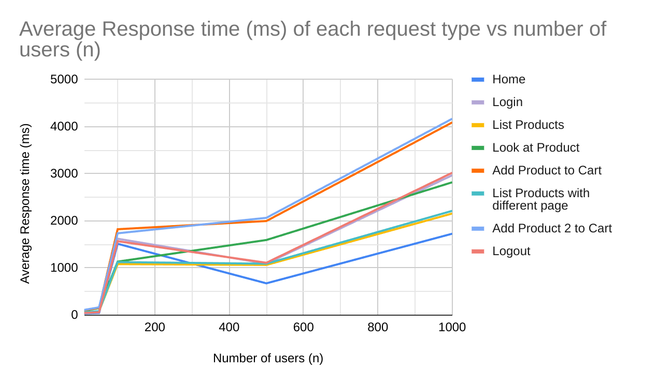

- Same graph as Fig. 5 but cutting off at n = 1000

- 95% confidence interval of Average Response Time (ms) of each page
Number of users | 10 |  | 50
Number of users | lower bound | upper bound | lower bound | upper bound
Home | 19.96636997 | 54.43363003 | 44.74136549 | 48.45863451
Login | 37.14639022 | 92.45360978 | 75.98769885 | 81.61230115
List Products | 25.02347313 | 98.97652687 | 76.37281814 | 86.42718186
Look at Product | 33.48458388 | 156.9154161 | 142.9394157 | 153.8605843
Add Product to Cart | 39.56126281 | 165.6387372 | 149.7544453 | 162.6455547
List Products with different page | 31.03088165 | 91.36911835 | 79.68302902 | 88.31697098
Add Product 2 to Cart | 38.2859039 | 182.9140961 | 155.6320933 | 174.7679067
Logout | 26.09948278 | 65.10051722 | 58.91368211 | 63.88631789
Number of users | 100 |  | 500
Number of users | lower bound | upper bound | lower bound | upper bound
Home | 1134.45052 | 1893.94948 | 652.1425468 | 697.4574532
Login | 1203.688001 | 2039.911999 | 1066.954605 | 1119.845395
List Products | 762.9885045 | 1403.411496 | 1031.771763 | 1098.628237
Look at Product | 742.3378762 | 1529.662124 | 1525.902606 | 1663.297394
Add Product to Cart | 1221.29338 | 2425.50662 | 1949.534865 | 2045.665135
List Products with different page | 727.9923372 | 1523.607663 | 1056.376749 | 1126.423251
Add Product 2 to Cart | 1273.931363 | 2200.468637 | 1993.993594 | 2136.806406
Logout | 1196.469689 | 1941.930311 | 1083.829933 | 1139.370067
Number of users | 1000 |  | 5000
Number of users | lower bound | upper bound | lower bound | upper bound
Home | 1574.648573 | 1881.351427 | 40620.17142 | 42684.62858
Login | 2740.386103 | 3198.813897 | 23753.96875 | 25389.63125
List Products | 1951.814801 | 2362.585199 | 7814.570615 | 8848.629385
Look at Product | 2614.083559 | 3026.316441 | 5875.913923 | 6657.286077
Add Product to Cart | 3817.058833 | 4364.141167 | 13052.25134 | 14754.54866
List Products with different page | 2000.248084 | 2427.351916 | 4609.634386 | 4920.365614
Add Product 2 to Cart | 3894.961275 | 4443.038725 | 13873.05478 | 14117.74522
Logout | 2782.427702 | 3262.372298 | 12586.94509 | 13091.85491

- Min and Max Response Time (ms) of each page
Number of users | 10 |  | 50
Number of users | min | max | min | max
Home | 18 | 185 | 17 | 152
Login | 34 | 283 | 31 | 253
List Products | 27 | 260 | 25 | 261
Look at Product | 39 | 471 | 35 | 462
Add Product to Cart | 47 | 444 | 42 | 426
List Products with different page | 27 | 264 | 26 | 215
Add Product 2 to Cart | 47 | 503 | 42 | 423
Logout | 23 | 165 | 20 | 187
Number of users | 100 |  | 500
Number of users | min | max | min | max
Home | 33 | 15490 | 18 | 3680
Login | 51 | 15884 | 34 | 4937
List Products | 35 | 14743 | 26 | 4512
Look at Product | 63 | 14365 | 42 | 6309
Add Product to Cart | 78 | 16187 | 44 | 6911
List Products with different page | 35 | 13913 | 28 | 4935
Add Product 2 to Cart | 83 | 16107 | 45 | 7087
Logout | 51 | 16082 | 18 | 4518
Number of users | 1000 |  | 5000
Number of users | min | max | min | max
Home | 18 | 7467 | 5 | 295860
Login | 31 | 10865 | 5 | 305157
List Products | 29 | 13205 | 0 | 282629
Look at Product | 41 | 14387 | 0 | 282628
Add Product to Cart | 47 | 10670 | 6 | 293290
List Products with different page | 26 | 13155 | 0 | 287750
Add Product 2 to Cart | 47 | 12727 | 6 | 295850
Logout | 20 | 10830 | 6 | 288718

Locust
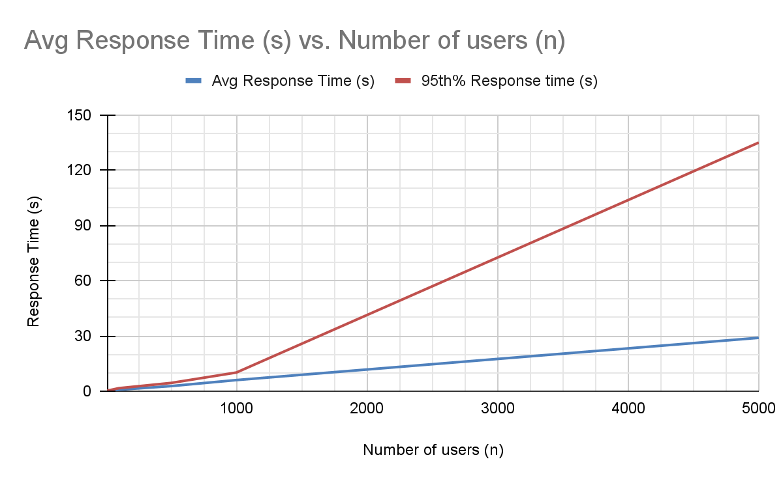
- Line graph of response times of TeaStore from Locus

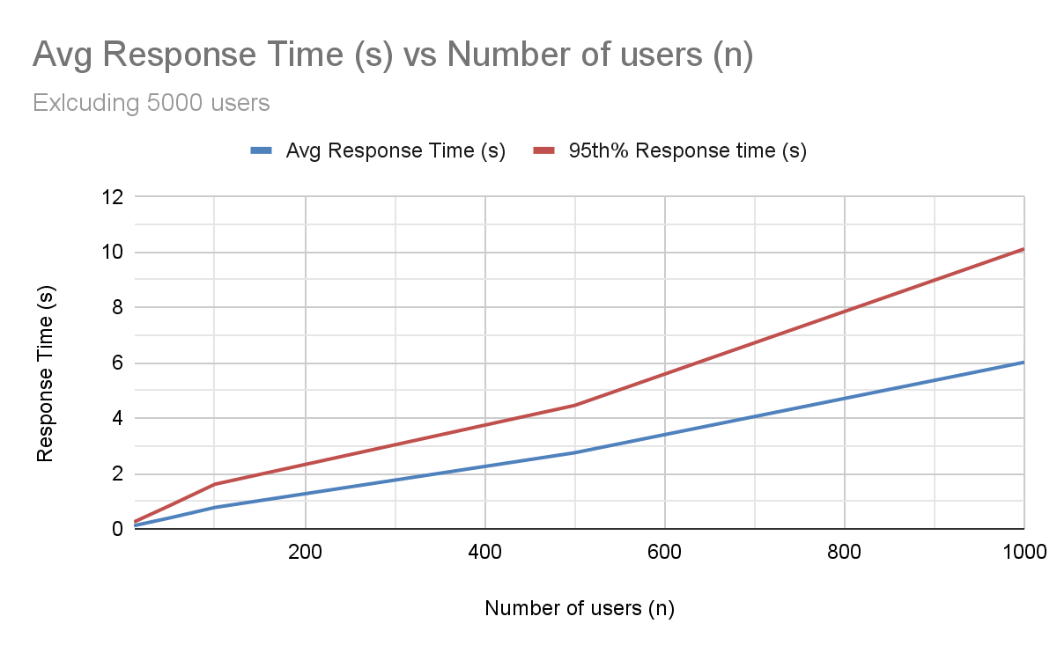
- Same graph as Fig. 7 but cutting off a n = 1000

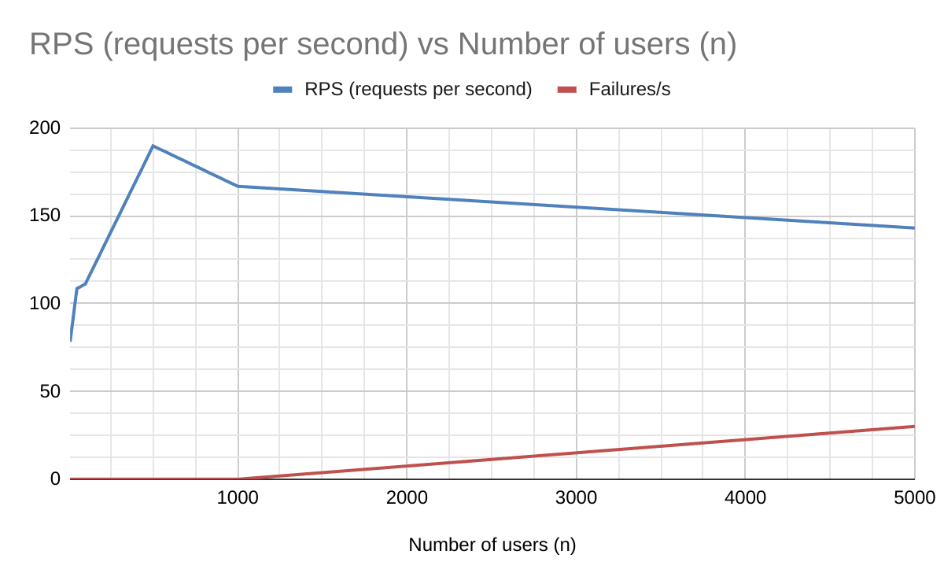
- Throughput of requests and failures of TeaStore from Locust

- TABLE 3: 95% confidence interval of Average Response Time (s) and 95% percentile response time (s)

Number of users (n) | 95% confidence interval Avg Response Time (s)
Number of users (n) | lower bound | upper bound
10 | 0.1084992652 | 0.1203043245
50 | 0.3825114639 | 0.4108352027
100 | 0.6772277588 | 0.8674555745
500 | 2.568771756 | 2.929130204
1000 | 3.945227627 | 8.093707885
5000 | 27.11161852 | 30.81953703
Number of users (n) | 95% confidence interval 95% percentile Response Time (s)
Number of users (n) | lower bound | upper bound
10 | 0.2384315649 | 0.2577735633
50 | 0.7457964256 | 0.9398702411
100 | 1.335190844 | 1.888142489
500 | 4.278644305 | 4.639002753
1000 | 5.173907916 | 15.05790036
5000 | 135 | 135

Conclusion
We won’t be directly comparing the response times between the Jmeter and Locust runs as they were running 2 different test plans and load ramp up; making them hard to directly compare.
From Figures 5 and 7, we can see between n=100 and n=500, the rate at which response time increases seems to decrease from before n=100. It is less apparent in Figure 8 average response time, however this effect can be seen better with the 95% response time. From n >=500 we get a rate where response time still increases but at a reduced rate from the startup to n=100. From Figure 9 we learned that the number of requests does not directly correlate with the number of failures. We determined from the graph that it was the number of users instead. A potential reason was the use of a Netflix Ribbon load balancer distributing requests to many services causing throughput to have no effect.

Suppose we set our expectation for the average response time for TeaStore to be 1s. This is a value chosen because it is on the lower end of response times but still bearable by a user, waiting a second for every action (our opinion). From Table 3, at 100 users the upper bound of the average response time is about 0.87s and from Figure 8 we can see the average response time reaches 1s in between 100 and 200 users. With such expectations, it would mean with the current setup TeaStore can handle a bit more than 100 users at once.
If we made our expectations a bit stricter, wanting the 95% percentile response time to be 1s so most of our users get 1s response time, then TeaStore would be able to handle a bit more than 50 users. From Table 3, at 50 users the upper bound of 95% response time is about 0.94s and at 100 users the lower bound of 95% response time is 1.34s (greater than 1 s).
If we want to improve TeaStore so it can handle more than 50 or 100 users at once, then optimizations will need to be made. From 100 users to 1000 users, from Figure 6, adding the first and second products to the cart has the highest response time from the request types. This suggests an improvement in adding products to the cart will have the greatest impact on lowering overall response time. In Figure 5, past 1000 users, we see loading the Home page and logging in as the highest rising in response times compared to the other requests made to TeaStore. This suggests that if the goal is to allow more than 1000 users to use TeaStore, improving Home page loading and logging in would be most beneficial to decreasing response time.

Experiment Improvements
An experiment design improvement that can be made is testing one or two numbers of users between 1000 and 5000. Currently, there is no way to see how response time jumps from having no failures to lots of failures. All we can tell is that there is a large jump, not how it gets worse. Did it get linearly worse or exponentially? Testing at 3000 users, or 2000 and 4000 users can help bridge the gap between 1000 and 5000 users and see the trend of the response times.
Another improvement is with the design of the Jmeter tests. Something that wasn’t considered was the fact that a user could finish their test plans before even all the users were spawned in. This became apparent in the 5000 user runs, however we are unsure if it also affects the 1000 or even 500 user runs. A solution to this would be to increase the number of times the test plan was executed. We ran with 5 times, hopefully increasing to 10 or even 20 can make each user last long enough so all the users can spawn in. This will make the Jmeter data reflect the concurrent user load we were planning to test on TeaStore, and not end up getting data for a lesser load.
An improvement to the experiment overall would be getting utilization data of resources. This can be found using Kieker, which is something the TeaStore repo provides has a section for running TeaStore with. We were unable to get Kieker to work, thus we were unable to get utilization data. Utilization data will allow greater insight into how TeaStore handles increasing loads as it allows us to see how the utilization of resources grows. With such data, we can potentially correlate response time of some pages to utilization of some resource or find there is no correlation at all.

References
Whenever TeaStore is mentioned within this paper, it is referring to [2]. The link to the Github repo is https://github.com/DescartesResearch/TeaStore.
Ref. [3] is never directly referenced in this paper. It is added to the list of references as the README in [1] said to cite it as [3] was the first place where TeaStore was published.
- F. Husain, FDIL501st/SENG-533-Project-Data (2024). https://github.com/FDIL501st/SENG533-Project-Data
- DescartesResearch, “DescartesResearch/TeaStore: A micro-service reference test application for model extraction, Cloud Management, energy efficiency, power prediction, single- and multi-tier auto-scaling,” https://github.com/DescartesResearch/TeaStore .
- J. von Kistowski, S. Eismann, N. Schmitt, A. Bauer, J. Grohmann and S. Kounev, "TeaStore: A Micro-Service Reference Application for Benchmarking, Modeling and Resource Management Research," 2018 IEEE 26th International Symposium on Modeling, Analysis, and Simulation of Computer and Telecommunication Systems (MASCOTS), Milwaukee, WI, USA, 2018, pp. 223-236, doi: 10.1109/MASCOTS.2018.00030. keywords: {Benchmark testing;Software;Analytical models;Resource management;Predictive models;Instruments;Microservice;Benchmarking;Performance;Power;Energy Efficiency;Models;Auto Scaler;Container;Cloud},
- Eismann, Simon & Bezemer, Cor-Paul & Shang, Weiyi & Okanović, Dušan & van Hoorn, André. (2020). Microservices: A Performance Tester's Dream or Nightmare?. 10.1145/3358960.3379124.
- dylanraps, neofetch (2021). https://github.com/dylanaraps/neofetch.

